**Curriculum vitae**

**Personal Information**

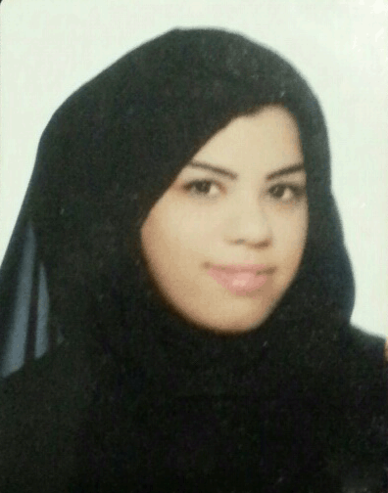

**Name**: Hawra Hassan Mulla Ahmed Altublani

**Date of Birth**: 15 July 1990

**Nationality**:Bahraini

**CPR Number**: 900704373

**Marital Status**: Married

**Address**:Home2338, Road427, Sitra-ALqaria604, Bahrain

**Telephone**:(Mobile) : (973(33973676

**E-mail**: hawraaltublani@gmail.com

**Education**

|  |  |  |
| --- | --- | --- |
| **Qualification Received** | **Institute/ School** | **From - To** |
| Bachelor Degree in Mass Communication - E-Communication | University of Bahrain | 2008 - 2014 |

**Activities**

Participation Presence in Education Association Symposium “Our young people - volunteered and creativity” Organized By College Of Education At The University Of Bahrain. From 31MAR – 2 APRIL . 2009

Participation in the organization Conference Regional Consultation on the Adaptation of UNESCO’s Model Curricula for Journalism Education in GCC Countries in section Media Committee. From 8 to 10 DES 2009.

Participation Presence in IT Symposium 4 “IT GOES GREEN” Organized By College Of IT At The University Of Bahrain.From 31ST OCT – 1ST NOV . 2010

Participation in the workshop production principles and TV output hosted by the Media Club at the University of Bahrain for the academic year 2009-2010

**Skills And Abilities**

**Interpersonal skills**: Cooperative person, Communication skills, Team work , Self Command & Independency At Work

**Software**: Adobe(Photoshop, ,Indesign,Dreamweaver,Audition,Premiere )

**Computer skills**: Microsoft Office

**Writings:** Journalism Article, Investigation,News

**Languages**: English and Arabic

**Additional skills**: Valid Bahrain Driving license.

**Interests**

Reading newspaper, Social networking , Surfing the internet .

**Reference**

**DR. Amani ALhalwachi** (Professor of electronic media at the University of Bahrain)

**Email** : [dr.amani.alhaleachi@gmail.com](mailto:dr.amani.alhaleachi@gmail.com)

**Mobile**: (973)36999190

**DR. Fareed Albayat** (Photographer and Professor of media at the University of Bahrain )

**Email:** [fareed_uob@yahoo.com](mailto:fareed_uob@yahoo.com)

**Mobile:** (973)39696377

**DR. Kamal ALgharbi** (Professor of electronic media at the University of Bahrain)

**Email:** [kgharbi@arts.uob.bh](mailto:kgharbi@arts.uob.bh)

**Mobile :**(973)39167211